Airport Data Insights: Data set description
Project for Data Comes Alive (Industrial Data Pipeline Basics)

Dataset Description
This dataset is a simulated event-based sensor log of airport baggage handling, covering a time span of three months. It consists of around 2880 rows, with 8–10 sensor events recorded per day. Each row corresponds to a single sensor event for a specific bag, capturing its movement through the airport system. The dataset is designed to track bags from entry to exit, enabling analysis of system efficiency, detection of bottlenecks, monitoring of sensor performance, and evaluation of overall operational performance.
Note: This dataset is synthetic and was generated using ChatGPT (OpenAI) to resemble realistic baggage handling system sensor logs for educational purposes.

Control System / Process Workflow
Here is a pictorial representation of the baggage handling control system.
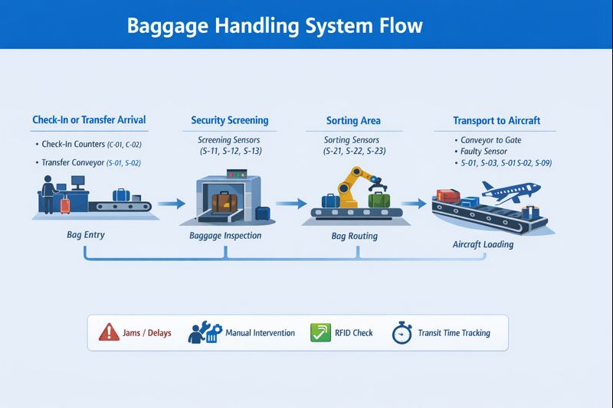
Each bag in the system passes through a sequence of steps controlled by sensors and automated conveyors as follows:
Step | Process | Description | Sensor Examples
1 | check-in or transport | Bag enters the system at the airport (check-in for new bag, transport for transfer) | C-01, C-02, S-01, S-02
2 | screening | Security screening / X-ray / inspection | S-11, S-12, S-13
3 | sorting | Bag is routed to the correct zone/flight | S-21, S-22, S-23
4 | transport | Bag moves to aircraft loading conveyor | S-01, S-02, S-03, S-09
Notes:
- Most bags follow all four steps.
- Transfer bags may skip check-in or have slightly different entry sensors.
- Each step is recorded as one sensor event.
- Timestamps allow calculation of total transit time per bag: first timestamp = entry; last timestamp = exit.

Data Dictionary
Variable | Type | Meaning / Units / Notes
timestamp | datetime | Timestamp of the sensor event (YYYY-MM-DD HH:MM:SS)
day | int | Day index (1–90)
hour | int | Hour of the day (0–23)
bag_id | string | Unique bag identifier
flight | string | Flight the bag is scheduled to board next
terminal | string | Terminal where the event occurred (T1, T2, T3)
zone | string | Zone within baggage handling system (Zone_A, Zone_B, Zone_C)
sensor | string | Sensor ID recording this event
process | string | Step in process: checkin, screening, sorting, transport
speed | float | Conveyor or vehicle speed (m/s); applicable for transport/check-in
vibration | float | Mechanical vibration at sensor (mm/s)
temp | float | Equipment temperature (°C)
rfid_ok | int | 1 = RFID tag read successfully, 0 = failed
jam | int | 1 = jam detected at sensor, 0 = none
intervene | int | 1 = manual intervention required, 0 = none
priority | int | 1 = high-priority bag, 0 = normal
result | int | 1 = process step successful, 0 = failed
screen_delay | float | Delay in minutes caused by screening (screening only)
vehicle_delay | float | Delay in minutes during transport (transport/checkin only)

References
1. OpenAI. (2026). ChatGPT (GPT-5.2): Synthetic baggage handling sensor dataset. https://chat.openai.com
2. Vanderlande Industries B.V. (n.d.). BAGFLOW: The end-to-end approach to baggage logistics. Retrieved January 27, 2026, from https://www.vanderlande.com/airports/solutions/bagflow/

